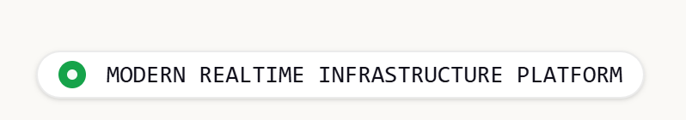
UNIFIED INDUSTRIAL OPERATIONS PLATFORM

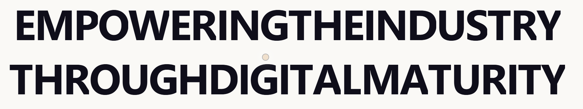
DRIVING INDUSTRIAL OPERATIONS
THROUGH REALTIME INTELLIGENCE
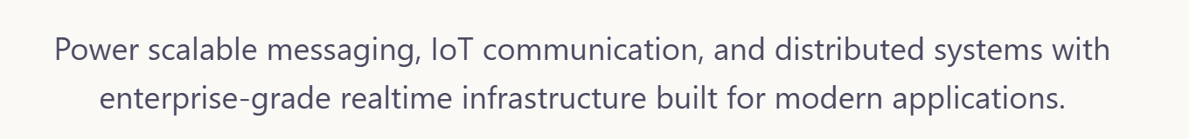
Altrex enables real-time monitoring, industrial connectivity,
asset management, GIS visualization, alarm management,
fleet tracking and operational intelligence through a
single unified W! Platform.

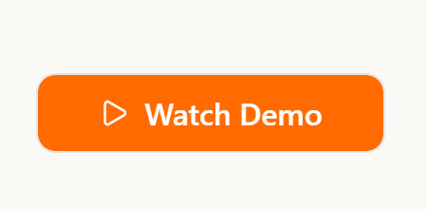 Request Demo + Explore Platform

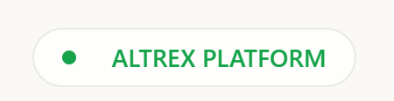 W! Platform

Enterprise Capabilities for Industrial Digital Transformation
Built for utility operators, manufacturing facilities,
energy infrastructure, smart cities and mission-critical
industrial environments.

CONNECTIVITY
Description –
Connect PLCs, RTUs, flow computers, analyzers,
energy meters, SCADA systems and edge gateways
using industry-standard protocols.
Bullets –
Modbus TCP/RTU
OPC UA
MQTT
REST APIs
BACnet
IEC-104
DNP3
Custom Industrial Drivers

SECURITY
Description –
Secure industrial infrastructure with IEC-62443 aligned
architecture, role-based access control, MFA and
encrypted communications.
Bullets –
IEC-62443 Aligned Design
Role Based Access Control
Multi-Factor Authentication
Audit Trails
Encrypted Communications

LIMITLESS MODEL -> UNIFIED DATA MODEL
Description –
Manage unlimited devices, tags, assets, users,
locations and operational data through a centralized
industrial information model.
Bullets –
Assets
Devices
Tags
Users
Sites
Hierarchies
Digital Twins

INTELLIGENCE
Description –
Transform operational data into actionable insights
through alarms, KPIs, analytics, reporting and
predictive intelligence.
Bullets –
Alarm Management
KPI Dashboards
Predictive Analytics
Report Scheduler
Event Processing
Operational Insights

VISUALIZATION
Description –
Visualize rich operational dashboards with GIS mapping,
asset tracking, trend analysis and enterprise reporting.
Bullets –
Realtime Dashboards
GIS Mapping
Asset Tracking
Trend Analysis
Reporting
Mobile Access

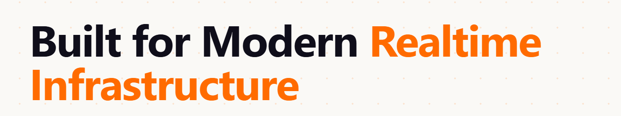
Built for Enterprise Industrial Operations

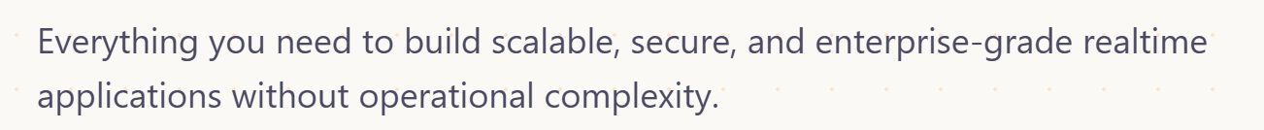
Everything required to monitor, manage and optimize
industrial infrastructure from a single W! Platform.

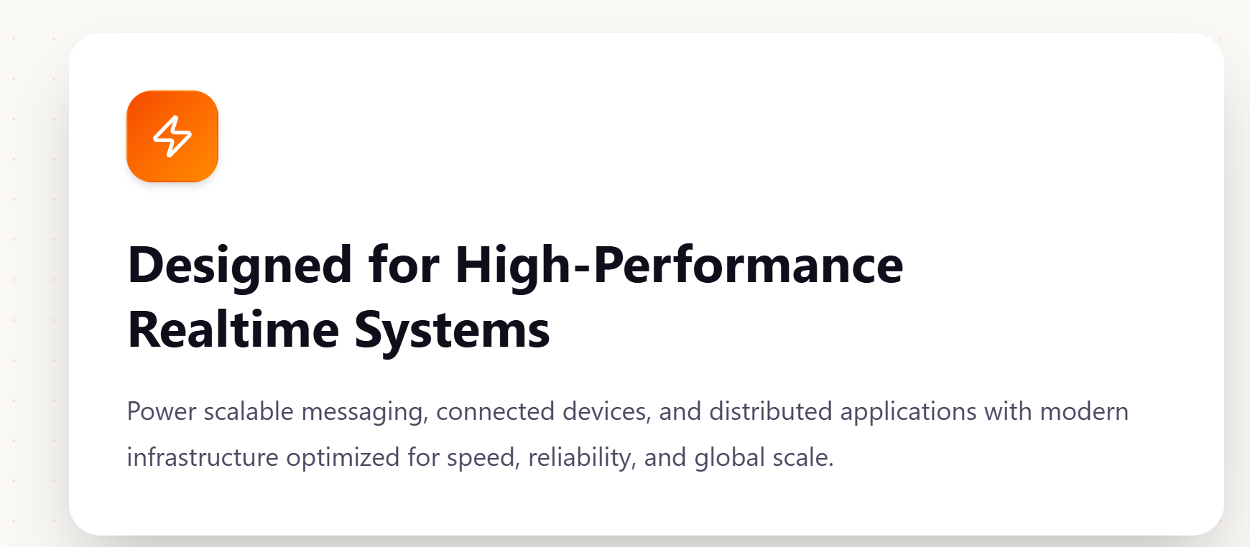
Designed for Mission-Critical Operations.
Deliver continuous visibility and control across
distributed industrial assets with enterprise-grade
reliability.

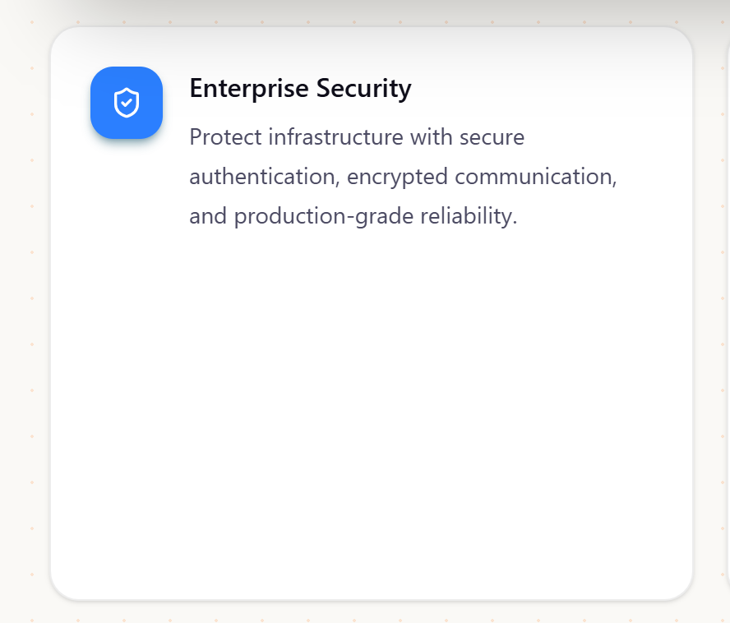(reduce height)
IEC-62443 aligned architecture
Multi-factor authentication
Role-based access
Comprehensive audit trails

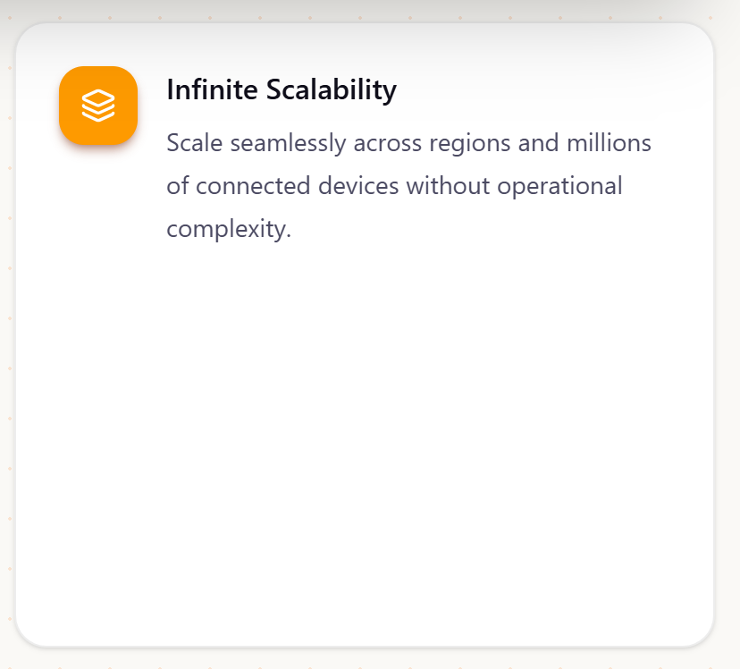 (reduce height)
Scale from a single site to thousands ofassets and millions of telemetry points.
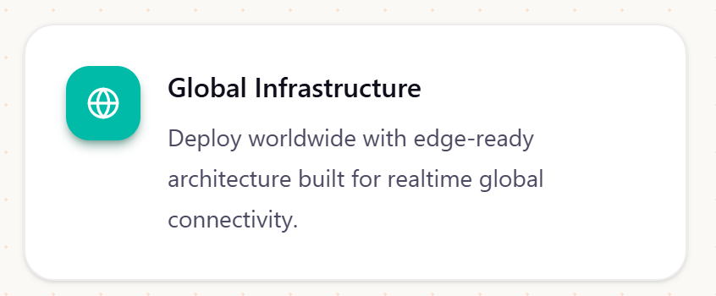
Deploy on-premise, cloud or hybrid environments with edge-ready architecture.

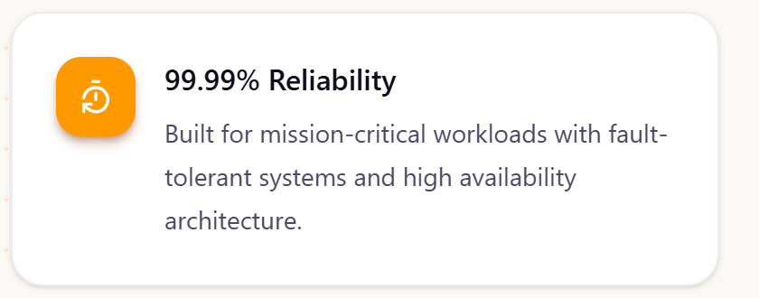
99.99% availability for mission-critical industrial operations.

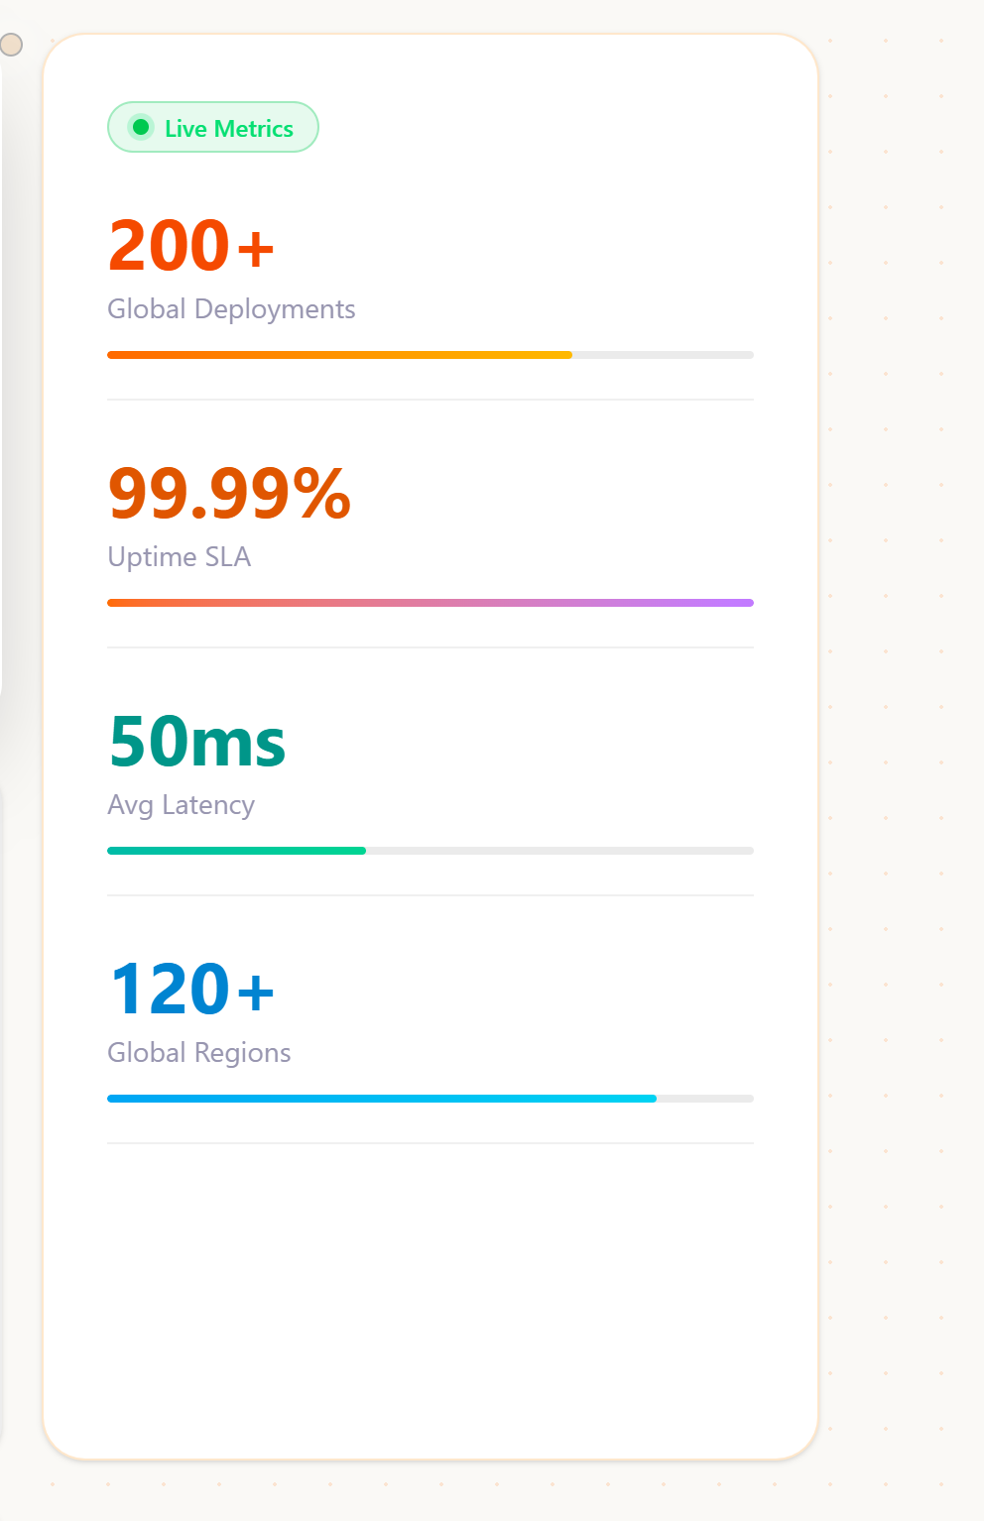

2K+
Connected Devices
10M+
Telemetry Events / Day
99.99%
Platform Availability
10+
Operational Facilities

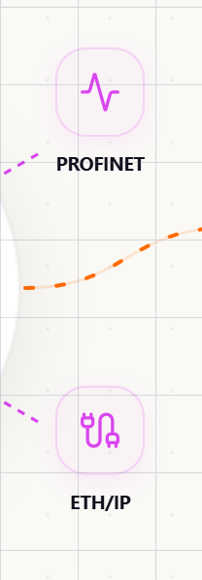 Replace with DNP3 & IEC-104


Purpose-Built for Industrial Operations

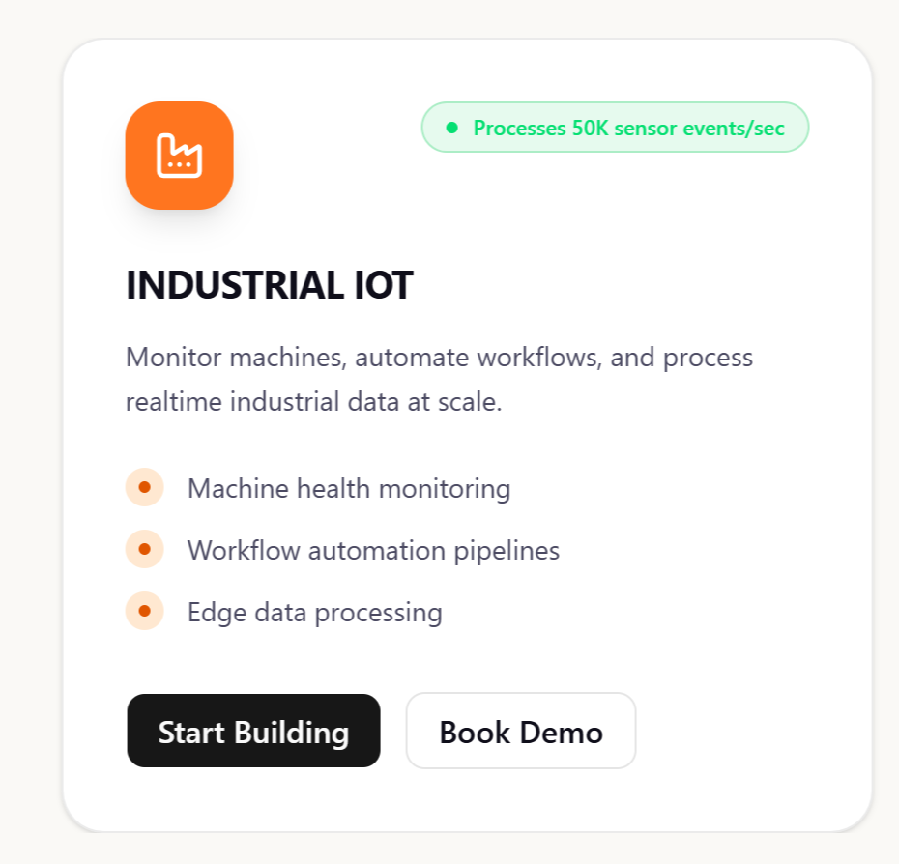
Bedge - Processes 50M+ telemetry events/day
Connect field devices, automate data acquisition, and monitor industrial operations across distributed environments.
Industrial protocol connectivity
Real-time telemetry acquisition
Edge-to-cloud data integration
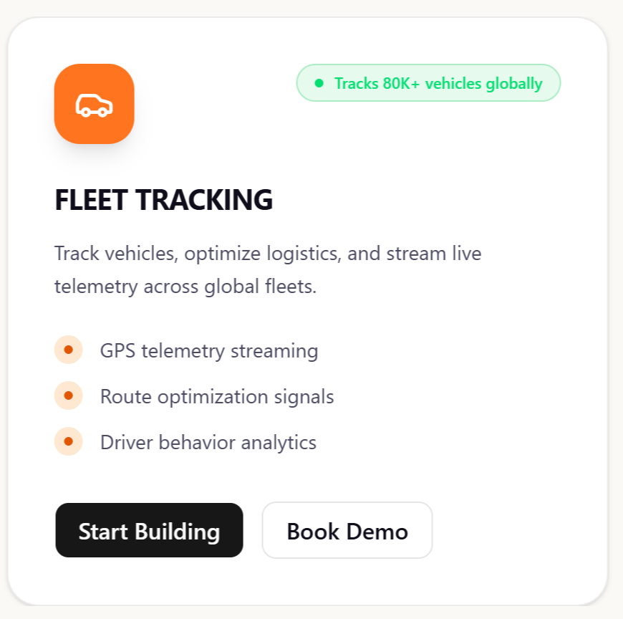
FLEET MANAGEMENT
Bedge - Tracks 50K+ Vehicles in Real Time
Manage connected vehicles, improve operational efficiency, and enhance fleet safety through intelligent tracking and analytics.
Live vehicle tracking and route optimization
Driver performance and safety monitoring
Maintenance scheduling and operational reporting

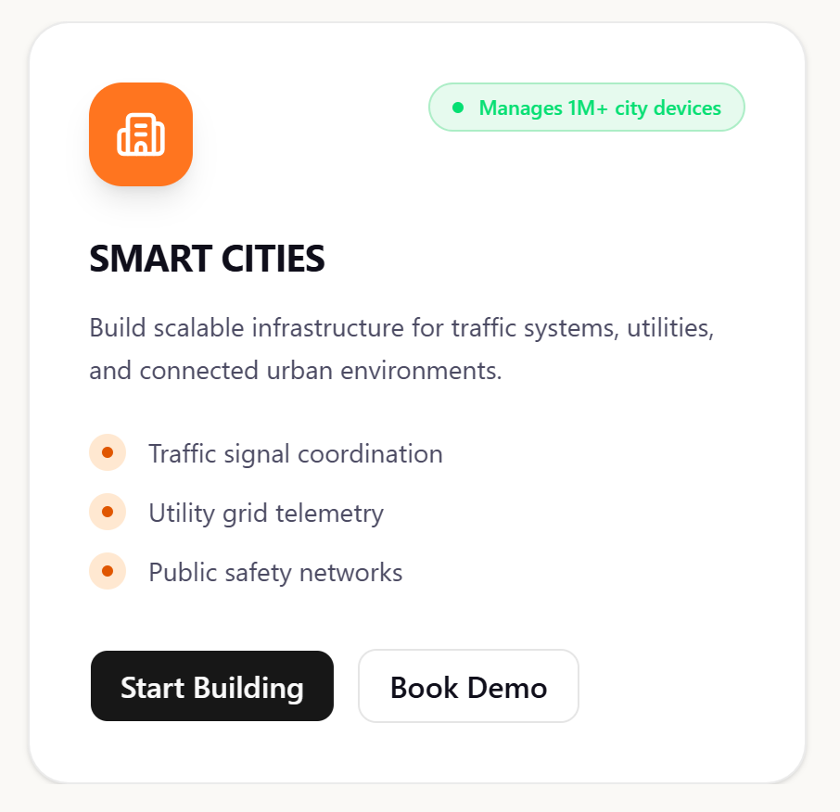
PIPELINE & GAS NETWORKS
Bedge - Monitors 10K+ field assets
Monitor gas distribution networks, pressure stations, flow parameters, and critical infrastructure assets in real time.
Remote Monitoring of CNG Stations
AMR Infrastructure of Gas Meters
GIS-based Network & Cascade Vehicle Management

ENERGY MANAGEMENT
Bedge - Monitors 50K+ energy points
Monitor energy consumption, demand patterns, power quality, and operational efficiency across facilities and infrastructure.
Real-time energy consumption monitoring
Demand and power quality analytics
Automated reporting and efficiency insights

GIS & ASSET MANAGEMENT
Badge - Manages 500K+ assets
Visualize infrastructure assets geographically and manage lifecycle, maintenance, and operational performance from a unified platform.
Interactive GIS-based asset visualization
Asset lifecycle and maintenance management
Location-based operational intelligence

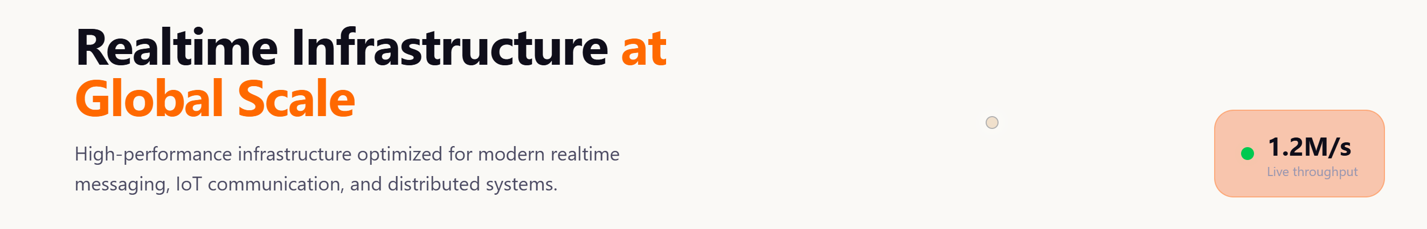

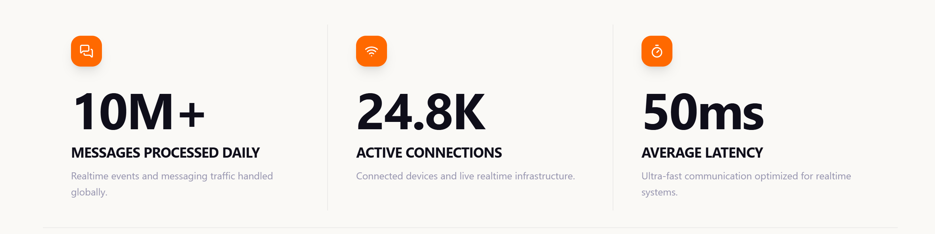
2K+
Connected Assets
10M+
Daily Data Points
10+
Industrial Deployments

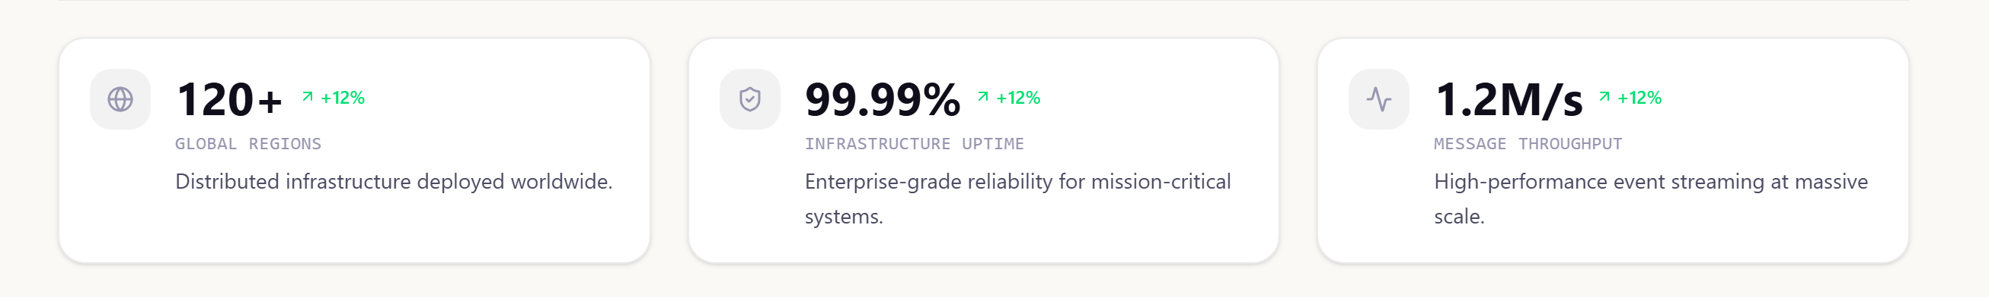
120+
Operational Sites
99.99%
Platform Availability
24x7
Operational Monitoring

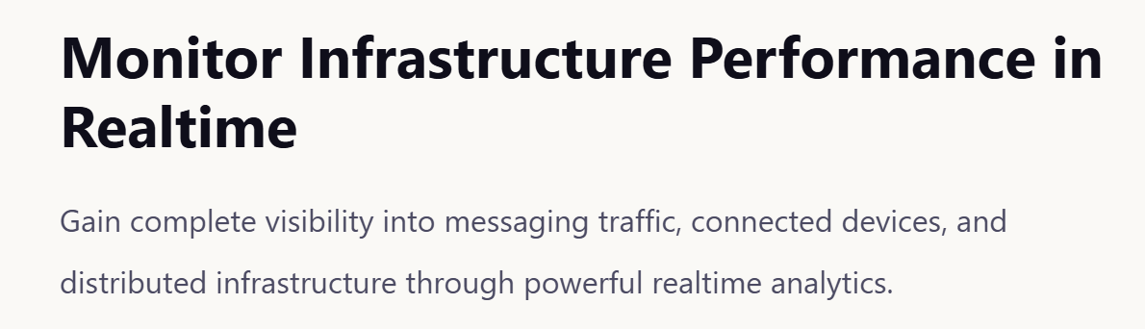
Transform Operational Data into Actionable Intelligence
Monitor assets, alarms, KPIs and operational trends through powerful analytics and reporting tools.

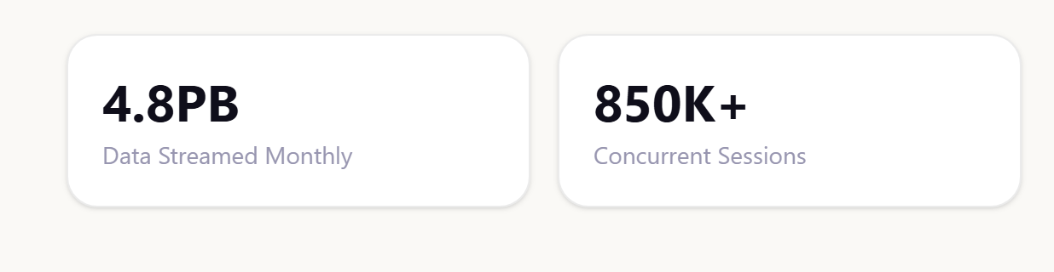
100M+
Data Points Processed Monthly
500K+
Concurrent Asset Updates

